Launch the Portal using the url :
https://egf-test1b.kabeldeutschland.de/

Expected : Two seprate tiles are appeared for the Vodafone and O2

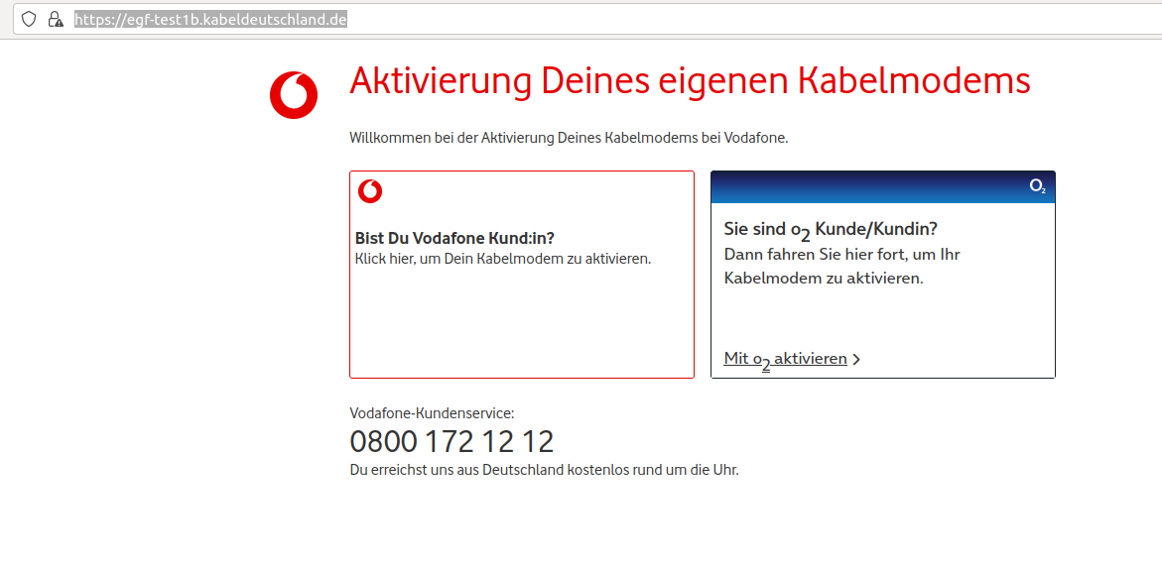
Click on O2 :

Mit o2 aktivieren link : it should redirect to the https://egf-test1b.kabeldeutschland.de/O2info and static page should appear containing the O2 information

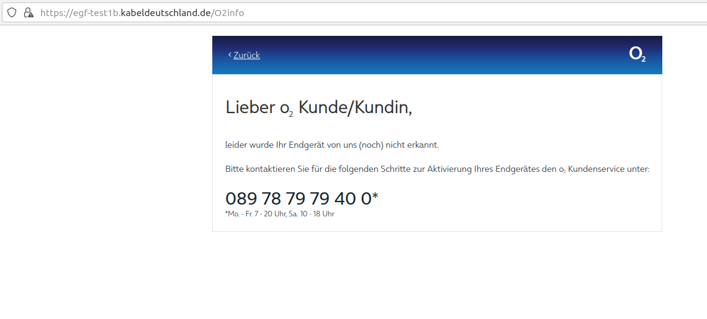
Click on Zuruck link to go back to the main page:

Its redirected to the https://egf-test1b.kabeldeutschland.de/

Click on the Vodafone tile, and it redirec to the “Aktivierung Deines eigenen Kabelmodems” page :

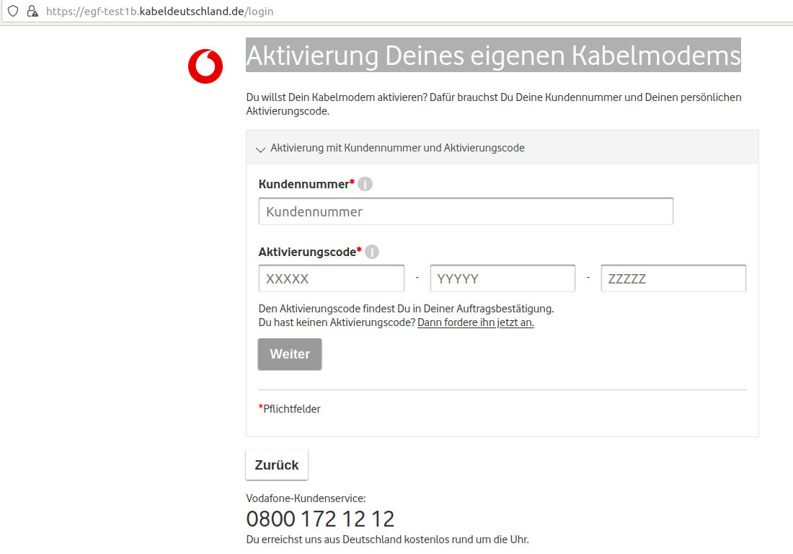
Click on the “i” symbol besides the Kundennummer tilte which is mandatory :
Hint window displayed :

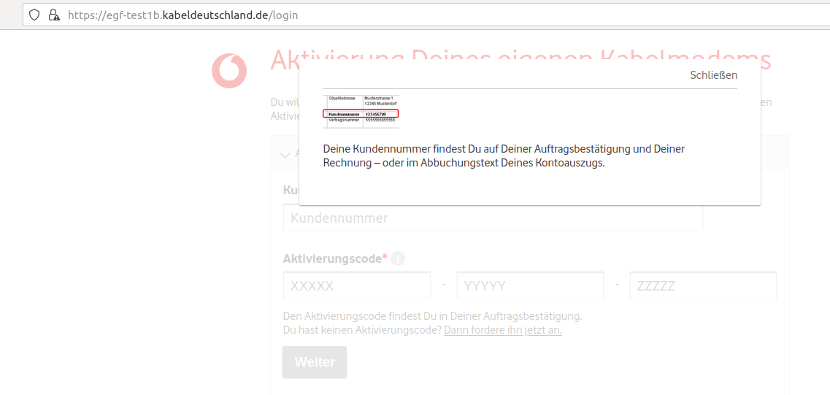

Next we can see the “i” symbol besides “Aktivierungscode”
again Hint window displayed:

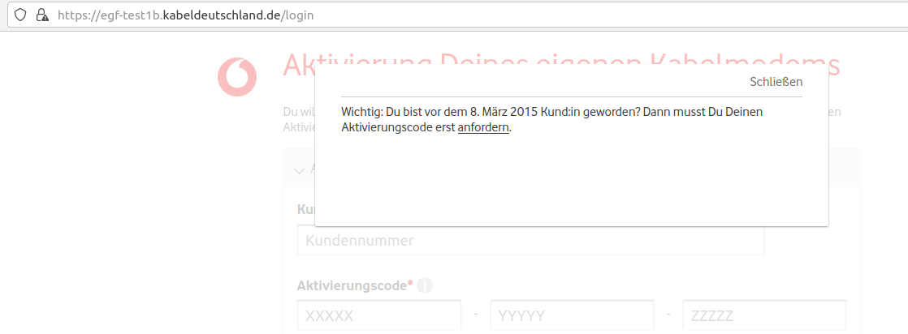

Click on the anforden link :
It gets redirected to the request activation page:

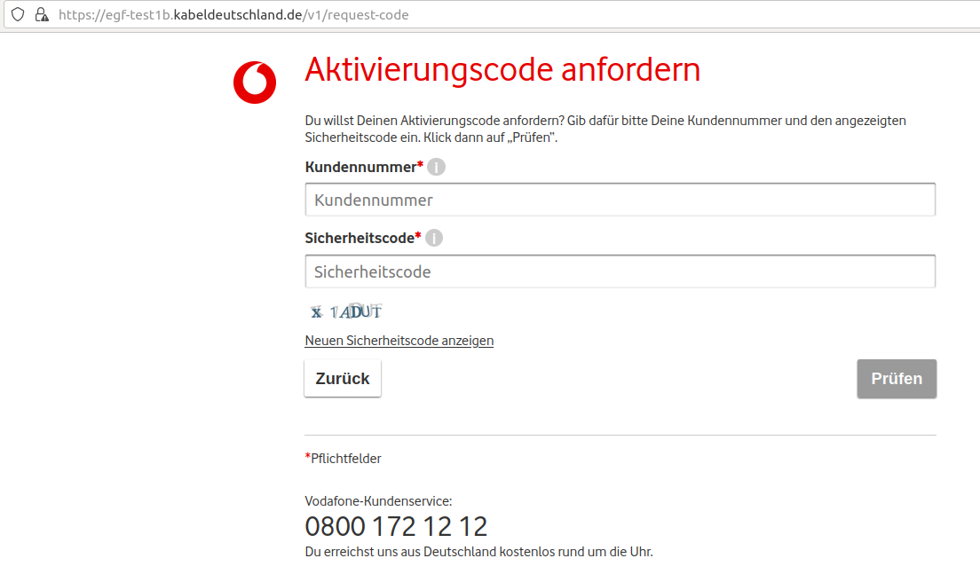
Click on Zuruck button to go back to the login page

Put some customer no and activation code from the qatools, and try to login:

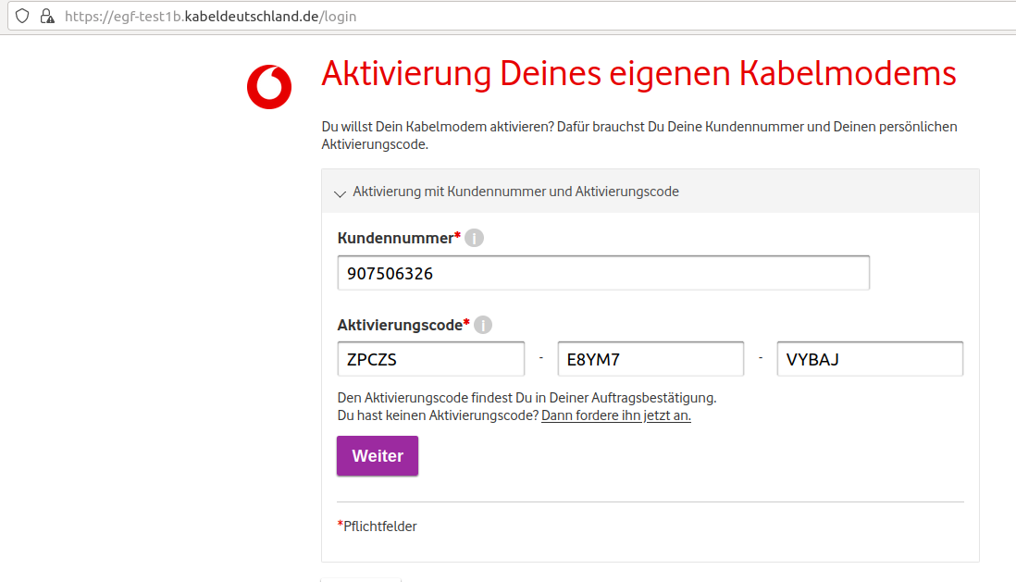

Should get error message and link to go back to the main page :

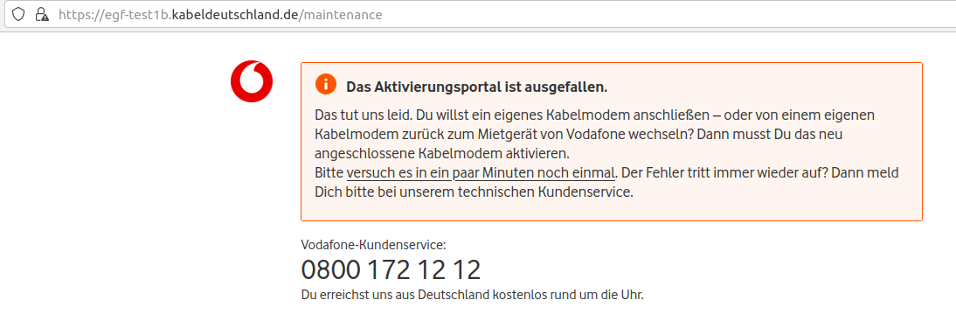

Click on versuch es in ein paar Minuten noch einmal to goback to the main page
